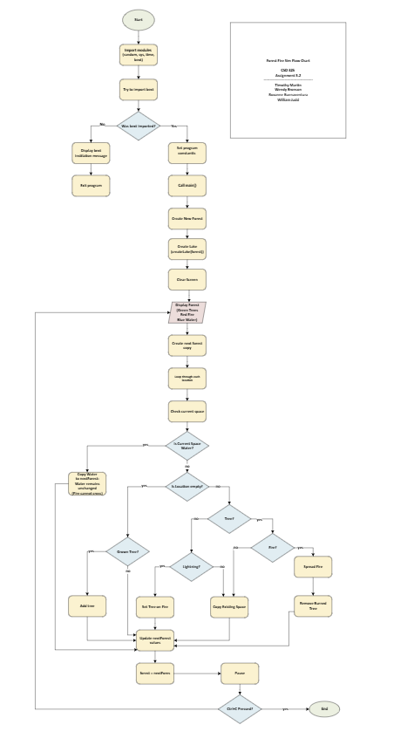
Assignment 6.2: Forest Fire Sim Group D
CSD 325
July 5, 2026
Timothy Martin
Wendy Bronson
Roxanne Buenaventura
William Judd

Github

